Federating FutureGrid and GENI
Ilia Baldine (ibaldin@renci.org RENCI/ UNC-CH),
Jeff Chase (chase@cs.duke.edu, Duke University),
Geoffrey Fox (gcfexchange@gmail.com IU),
Gregor von Laszewski (laszewski@gmail.com IU)

Introduction
In the last few years a number of projects have begun creating complex testbed environments that serve a variety of domain sciences. These testbeds leverage various cloud and networking technologies to create rapidly reconfigurable environments in which user activities can take place. The creators of these testbeds have designed sophisticated solutions that address the specific needs of their user communities, which created sets of unique complementary capabilities between them. As the level of sophistication of users grows, their requirements to the testbed environments are expanding, such that no single environment may be able to meet their needs. Thus there is a need to federate these previously separate efforts to allow users to gain access to the best of breed solutions, while taking advantage of federated identity and other mechanisms that simplify access to resources from multiple providers. In this document we discuss the possibility of federation between FutureGrid and GENI - two such testbed efforts.

FutureGrid is an international testbed infrastructure for researchers of various domains (see Figure 1). One of its uses has been to tackle complex research challenges in computer science related to the use and security of grids and clouds. These include topics ranging from authentication, authorization, scheduling, virtualization, middleware design, interface design and cybersecurity, to the optimization of grid-enabled and cloud-enabled computational schemes for researchers including domain scientists. FutureGrid has delivered not only the ability to utilize IaaS and PaaS to the users, but also provides provisioning of templated images onto IaaS and even bare metal. Technologies that are relevant for the collaborative work include FutureGrids templated image management, bare metal provisioning of OS distributions that are popular as part of IaaS developers (especially OpenStack), the FutureGrid templated experiment management for IaaS and PaaS including Hadoop, and cloud metric framework allowing integration with accounting frameworks. FutureGrid has also provided a sophisticated portal for user and project management allowing the approval of user accounts and projects through a well defined distributed process that makes it possible to support approval within minutes. Recently, we have also started efforts to couple the available resources into online educational Massive Open Online Course services.

GENI was envisioned as a sophisticated global environment for staging complex computer science experiments on a large scale, combining computational, networking and storage resources into complex connected arrangements called slices in a federated setting which included resources from multiple providers. However as GENI began to take shape, it became apparent that the solutions developed to create isolated slices suitable for scalable distributed experiments, can also be used for launching complex distributed computational activities. GENI architecture and engineering efforts paid particular attention to (a) resource descriptions and network virtualization, enabling complex network topology embedding at Layer 2, which bypasses the commodity Internet, and (b) federation identity mechanisms, where e.g. at the time of this writing ABAC (Attribute Based Access Control) - an advanced authorization scheme base on reasoning over an authorization logic, is being integrated.

GENI consists of several substrate elements, which are being federated together to allow users seamless access to a variety of resources: computational and storage resources from GENI ‘racks’, Layer 2 backbone resources from NLR and Internet 2 and OpenFlow resources from overlay networks hosted by backbone and regional providers. RENCI has been deploying part of GENI testbed called ExoGENI (http://www.exogeni.net) since 2012. When completed, ExoGENI will consist of 14+ rack sites across the US and the world, tied together with Layer 2 backbone and OpenFlow networks, capable of staging slices that include resources from multiple racks tied together with VLANs acquired from multiple Layer 2 providers (at present 6 sites have been deployed and the deployment process is continuing). ExoGENI is based on an overlay model in which the federation and orchestration software called ORCA (developed by Duke University and RENCI) controls existing cloud and network aggregates (e.g. OpenStack installations and regional and global network providers) via their native APIs. ORCA includes sophisticated network embedding capabilities and can be modified to control additional cloud and network resources due to its pluggable architecture and implementation.

Thus the two testbeds represent a significant set of resources leveraging cloud technologies, which present a complementary set of capabilities: image management, application level control in FutureGrid and identity federation and network virtualization in ExoGENI/ORCA.

We propose to undertake a development effort to allow FutureGrid resources and capabilities to be leveraged using GENI federation mechanisms as well as ORCA topology embedding and network virtualization. This would allow FutureGrid users to take advantage of ORCA’s advanced networking capabilities and federation mechanisms (e.g. identity), while GENI users would gain access to a unique resources in FutureGrid for staging experiments that involve diverse computational cloud resources, which include FutureGrid’s sophisticated compute image management capabilities.

Driving Applications and Use Cases

In this section we identify a number of areas and user communities which would benefit from FutureGrid offering some of its capabilities under GENI federation. They can be roughly separated into three categories:
- Area 1. Users of FutureGrid, who would benefit from expanding their activities into GENI using its advanced networking capabilities
- Area 2. Users of GENI, who would benefit of using features and tools of FutureGrid
- Area 3. GENI architectural and development activities that can benefit from experience and tools developed by FutureGrid
Furthermore, we are highlighting within each of the areas of promising research activities that would benefit from such an integration.

Area 1.
(a) Distributed big data applications

As data volumes grow, there is much interest in data repositories and data intensive computing. Scientists need systems that manage both the data and provide computing (data analytics) on the data. Recent commercial systems such as those at Google, Facebook, Amazon, Twitter are architectured as a clouds supporting analytics with co-located storage. These satisfy the principle of bringing computing to the data. However, this is not universally applicable for the cyberinfrastructure supporting data-intensive science, which features a diversity of distributed data analyzed by a distributed research team. We have good examples in the LHC data analysis system with data distributed and analyzed across the world. The primary data analysis of LHC uses compute-data affinity in a grid to produce event parameters, but also needs to access data across the globe, making it more efficient (as only parts of distributed files are needed) than transferring files. However, this pleasingly parallel model is insufficient in other disciplines where one traditionally uses repositories like GENBank (Biology), NSIDC (Polar data) and EOSDIS (Earth Satellite data), which do not have enough attached computing to support science analysis. We can imagine adding a cloud in front of each discipline repository but how do we determine the right size and scalability for it? Further suppose we want to do environmental genomics; we need genomics as well as environmental data, which are typically not in same repository as they are gathered by multidisciplinary studies. Even in genomics itself, data is now gathered by a multitude of distributed low cost “individual” sequencers such as the Illumina MiSeq which has an instrument cost of ~$100K and can produce many gigabytes of data a day. This analysis highlights a new frontier, where data is stored in multiple places across continents but needs to be presented to the analytics as a co-located data system perhaps set up as virtual Hadoop file system.

Early experiments on the FutureGrid-GENI collaboration will focus on building and measuring performance of virtual distributed data stores where GENI-based software defined networks bring the computing to distributed data repositories. We will compare this streaming virtualized data model with the traditional model where files are copied from distant to local storage. We will consider multiple data architectures including HDFS (data parallel storage with addons like Hbase), Lustre (wide area file systems) and the object stores exemplified by Amazon S3 and OpenStack Swift. Example applications already on FutureGrid include Network Science (analysis of Twitter data), “Deep Learning” (large scale clustering of social images), Earthquake and Polar Science (exemplifying the important Earth Science area with multidisciplinary climate change and need to fuse geo-positioned data from multiple sources), Sensor nets as seen in Smart Power Grids and Genomics discussed above. The analytics needed include some pleasing parallel as in sensor data analysis; some with weak coupling as in Genomic sequence comparison as with Blast; others with interactive browsing as with Geographic Information Systems in Earth Science and closely coupled clustering seen in Genomics and Network Science. These analytics span performance issues including I/O dominated and communication intensive applications.

Thus the perennial tradeoff of moving data to computation or moving to computation acquires new dimensions with FG/GENI federation. With FG taking advantage of GENI network stitching and other unique networking capabilities, users of FG interested in data-intensive applications will be able to experiment with their applications in a much more widely distributed environment with a variety of computational capabilities. For example, their applications may ‘cloud-burst’ into GENI similar to EC2 cloud-bursting, but with the added advantage of more stringent guarantees of network performance, unachievable in the public Internet and with public clouds.

(b) Educational activities

GENI and FutureGrid can bring activities in regards to an integrated educational agenda to the user communities, while not only focussing on the unique expertise each of them provide, but also by integrating this expertise into a new set of material that can be exploited through MOOCs. FutureGrid has shown that such educational activities are also contributed by the community.

FutureGrid participants will both benefit from and contribute to the growing body of educational materials available for GENI experimenter community.

Area 2.
(a) Virtual IaaS, PaaS and SaaS

A significant value that FutureGrid and GENI can provide to the community is the creation of testbeds for the community allowing users not only to access a production system, but also to deploy and instantiate their own modified versions of the software stack. Undoubtedly, this is needed to develop the next generation cloud and network software and not just provide access to a production level system. The availability to the community of such environments is paramount towards scalability experiments.

By offering these services under the umbrella of GENI tools to GENI users, FutureGrid would benefit the GENI community by offering a wider range of capabilities, than available today

(b) Broadening technologies

GENI relies on a fairly narrow range of technologies to enable compute substrate provisioning. ProtoGENI uses Freesbee, while ExoGENI uses OpenStack and xCAT. The experience of the FutureGrid team with other cloud technologies (e.g. OpenNebula, Nimbus, CloudStack, see Figure 2) and the inclusion of these technologies into GENI federation, as part of the proposed effort, would broaden the acceptance of GENI (and the GENI model of federated resource provisioning) in other communities of interest.

FutureGrid tools like Rain as well as extensive cross-cloud FG image management capabilities would add unique features to the capabilities of GENI experimenters, by enabling their experiments to be launched on a variety of cloud platforms. This would allow meaningful comparisons and evolution of those technologies and spur innovations in this area.

Area 3.
(a) From Virtual to Baremetal Services

Once services are tested in virtual environments there is also a need for experimenting with them on bare metal, to contrast scalability and performance characteristics. The features that GENI and FutureGrid provide will be a useful extension as it allows to create templated images that can be first tested in a virtual environment and than be deployed on baremetal. Such an environment is also important to isolate the experiments from other influences and create a more clear understanding about how virtual and non virtual environments are influencing the services including infrastructure, platform and software.

This type of a transition is difficult in today’s GENI environment, however the federation between FutureGrid and GENI would present an opportunity to build this mechanism into the foundational set of GENI technologies, thus enabling new types of activities both in computational sciences as well as in computer science experimentation.
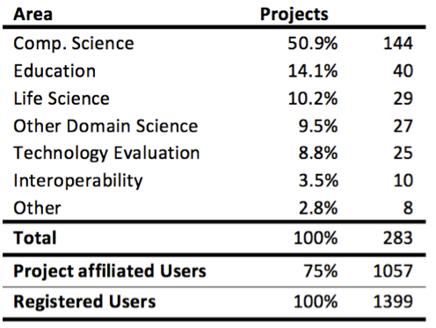 | 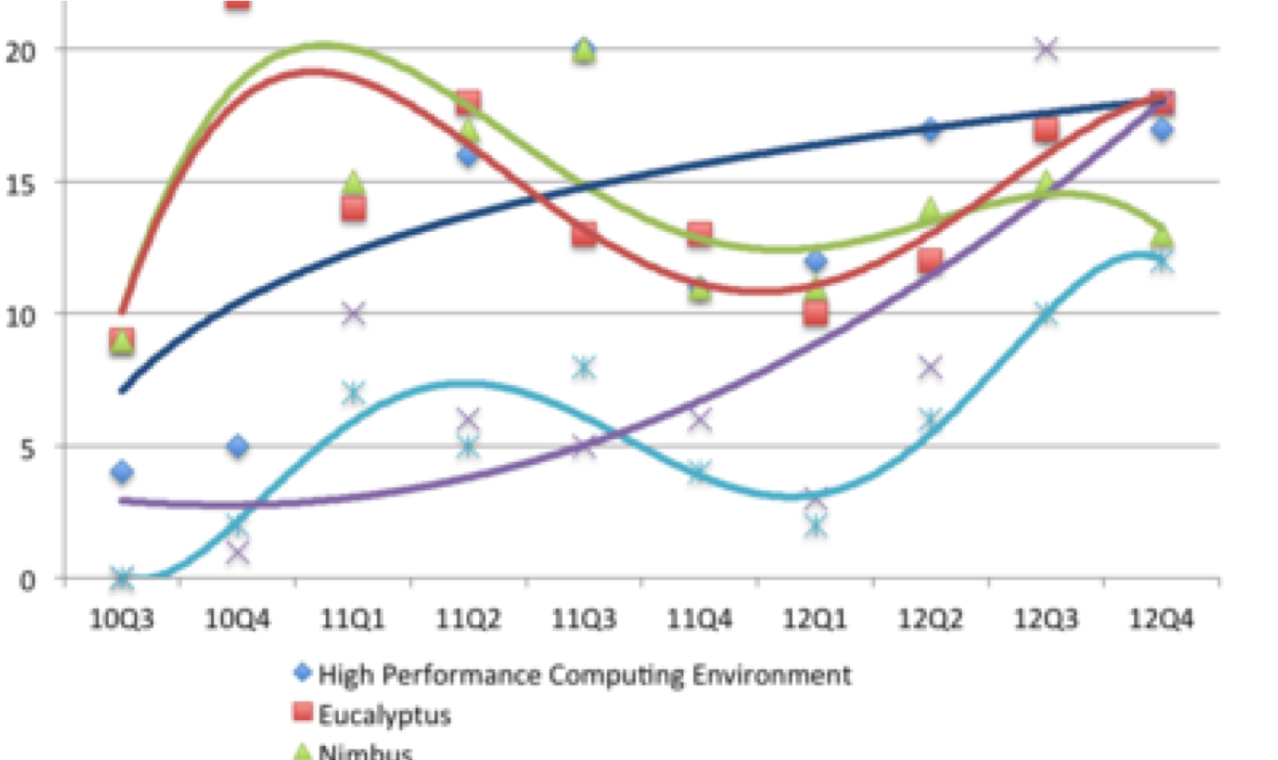
Figure 1. Distribution of the users on FutureGrid as Feb. 2013 | Figure 2. Technologies requested by the Project owners

Summary of proposed activities

Multiple steps will be required in order to achieve the federation between FutureGrid and GENI. The tasks will be undertaken jointly by IU, RENCI and Duke, leveraging their deep expertise in these areas. We propose the following progression:

Step | Description | Outcome
Initial integration between portions of FG using OpenStack and xCAT and GENI (using ORCA control framework) | Given that ORCA already manages OpenStack and xCAT installations, we expect a relatively minor porting effort aimed at equalizing Layer 2 networking capabilities between versions of OpenStack deployed in ExoGENI and FG.  This step would also involve enabling connections between FG and GENI using I2 Layer 2 backbone. | FG users with GENI credentials and regular GENI users will be able to use the FG as well as other GENI resources, connect them using GENI stitching with each other for the purpose of experimental activities.
Integration with FG tools | This step include deeper integration with FG tools (e.g. Rain) to support a broader range of traditional activities on FG using GENI tools and APIs.  While continuing to use OpenStack, we will investigate the necessary steps to enhance Layer 2 capabilities of other FG technologies (e.g. Nebula, CloudStack) in preparation for the following step.  This step would involve enhancing GENI resource description capabilities to enable the use of these FG tools. To simplify the integration we will be looking into defining an abstraction level that makes the integration with other bare metal provisioners possible. | Greater freedom for experimenters to use advanced FG tools under GENI resource descriptions and APIs.
Integration of other FG cloud technologies into GENI | Using the outcomes of the previos step expand the reach of GENI API and resource descriptions to encompass the full range of FG capabilities and cloud technologies. | Experimenters would be able to take full advantage of the FG infrastructure using GENI resource descriptions and APIs.
Development of Educational materials for services used in FG and GENI | Using the expertise of the two teams we will be developing new educational material that will focus on the newly available services to each community. | Users would have an easy time to use the resources in conjunction.

